**Work on project. Stage 6/8: The value of life**

## Description

The most recent version of the game is not so much fun, since we still don’t have a way to handle the player's victory. The player has 8 attempts to guess letters, and the number of remaining attempts decreases after each try even if the player guesses correctly.

In this next version, a player may get a lot of attempts because they are limited only by the number of mistakes they make. A player can be mistaken 8 times. They win when they have guessed **all** the letters and still have at least one try. If the player uses their last try and actually guesses the word, then they’ve won!

## Objectives

The player starts the game with 8 "lives", which is to say, our player can input a wrong letter 8 times.

1. Print That letter does not appear in the word and reduce the number of remaining attempts if the word selected by the program doesn't contain this letter.
2. Print No improvements and reduce the attempts count if the selected word contains this letter but the user has already tried guessing it.
3. The number of remaining attempts should be decreased only if there are no letters to uncover.

Please, make sure that your program's output formatting precisely follows the output formatting in the example. Pay attention to the empty lines between tries and at the end.

## Examples

The greater-than symbol followed by space (> ) represents the user input. Note that it's not part of the output.

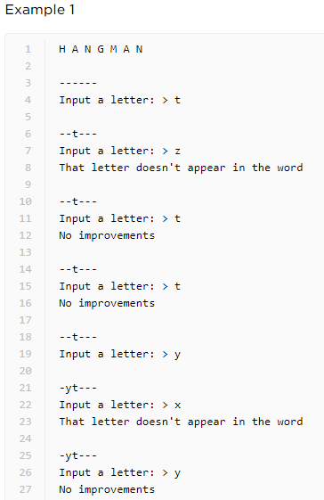

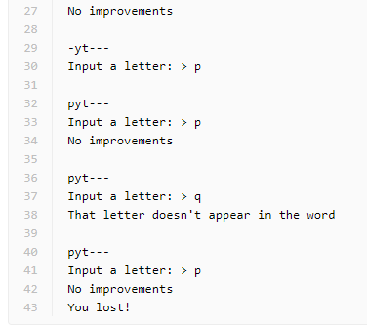

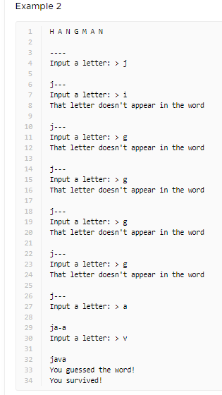

import random

# VARIABLES

lives = 8

words_list = ["python", "java", "kotlin", "javascript"]

word = random.choice(words_list)

hidden_word_list = list("-" * len(word))

input_list = []

# ---------------------------------------------------

# Game logic

print("H A N G M A N")

while lives > 0:

    print()

    print(f"{''.join(hidden_word_list)}")

    user_input = input("Input a letter: ")

    input_list.append(user_input)

    if user_input in word:

    #Check if the letter isn't already discovered

        if user_input in hidden_word_list:

            #if user_input in input_list:

            print("No improvements")

            lives -= 1

        for i in range(len(word)):

            character = word[i]

            if character == user_input:

                hidden_word_list[i] = word[i]

        if "-" not in hidden_word_list:

            print("You guessed the word!\nYou survived!")

            lives = 0

        elif lives == 0:

            print("You lost!")

    elif user_input not in word:

        lives -= 1

        #if user_input in input_list[:-1]:

        #   print("No improvements")

        #else:

        print("That letter doesn't appear in the word")

        if lives == 0:

            print("You lost!")